CDC-APHL Respiratory Syncytial Virus (RSV) Genomic Surveillance Guide for Public Health Laboratories
Overview
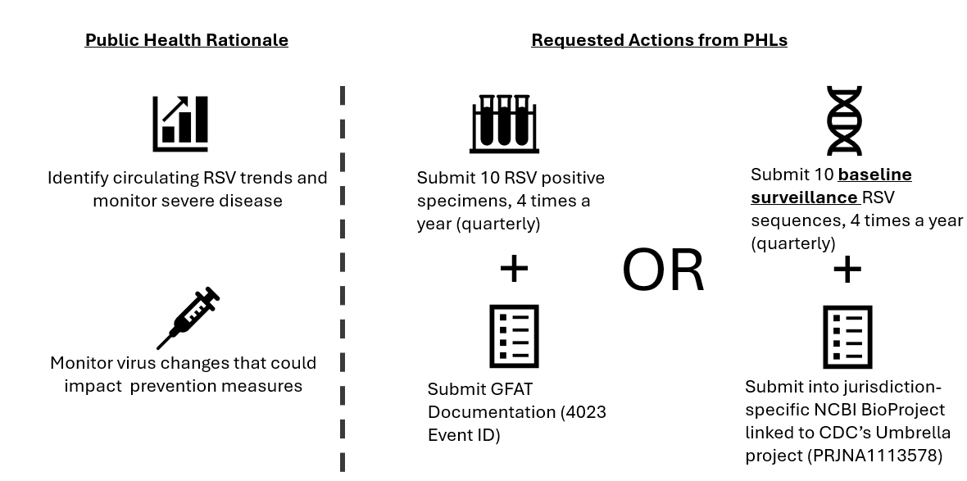
Background
CDC and APHL are seeking continued support from public health laboratories through routine participation in the establishment of systematic and ongoing molecular surveillance for RSV in the United States. Moreover, surveillance specimens submitted to CDC are critical to analyze national and global circulating RSV trends and increase publicly available baseline RSV sequence data. As a leading cause of hospitalizations among young children, this data is critical for monitoring severe disease burden. RSV vaccines became available for the first time in 2023 to protect those at increased risk for severe disease, including adults aged 60 years and older and infants (protected through maternal vaccination). In addition, a monoclonal antibody immunization option became available to protect infants and young children. Ongoing RSV surveillance will also help assess the effectiveness of these prevention measures.
Target Surveillance Specimen Submissions
Public health laboratories are encouraged to submit a maximum of 10 RSV-positive specimens each quarter (i.e., four shipments of 10 specimens each for 40 specimens total annually) to CDC for sequencing. Specimen selection and submission instructions are included in Appendix 1. Shipping costs will be paid for by APHL for up to four shipments annually. Shipping guidance is included in Appendix 2. RSV is classified into two circulating subgroups A and B. Participating laboratories are not required to have RSV subgroup assays. However, laboratories interested in implementing RSV subgroup real-time RT-PCR assays should contact the CDC Coronavirus and Other Respiratory Viruses Division, Laboratory Branch via sarsseq@cdc.gov.
Specimen Diversity
For each shipment, please submit RSV-positive specimens that are representative of observed RSV activity during that quarter.
Please only submit one representative specimen per outbreak. As a reminder, if your state needs assistance with any RSV-related or suspected outbreak, CDC is available to provide assistance, support and technical consultation, as appropriate.
Data Sharing of RSV Genetic Sequences
CDC and APHL will share results of further surveillance testing with the submitting laboratory director when these data are available. RSV genetic sequence data will be made publicly available in GenBank and/or to the submitting laboratory upon completion of aggregate analysis (usually done once or twice a year).
Sequence Tagging and BioProject Accessioning
RSV sequence data that is uploaded into public databases and intended to be used for national surveillance efforts should be cataloged. Properly tagging sequence data allows the submitting facility, CDC, and other users to quickly identify unbiased samples sequenced as part of the national surveillance effort and makes it easy to recognize contributions from the various laboratories. RSV sequences generated as part of “targeted” efforts (e.g. outbreak investigation) can bias baseline surveillance estimates and should not be tagged as baseline surveillance or included in baseline surveillance BioProjects, but they are still valuable to submit to public databases. Consensus sequence data should be uploaded to NCBI, other databases are optional, but it is valuable to submit raw read data to NCBI SRA.

The preferred method of tagging relies on NCBI BioProjects. Each jurisdiction should create a BioProject for RSV surveillance with their jurisdiction’s name. This BioProject should only contain specimens that can be considered baseline surveillance.
- These should be associated with CDC’s Umbrella BioProject: PRJNA1113578.
- Please email bioprojecthelp@ncbi.nlm.nih.gov to associate the local BioProject.
- Review Appendix 4 for additional detailed instructions.

Appendix 1: RSV Specimen Selection for Submission to CDC for Genomic Surveillance

- Specimen Selection
  - Submit a maximum of 10 RSV-positive specimens per quarter to CDC for further testing.
  - The quality of the specimen directly affects sequencing success.
    - Ideally, specimens should have an RT-PCR Ct value of ≤32.
  - Submit original clinical specimens with at least 500 µL volume and no more than 1 mL unless confirmed beforehand.
  - Acceptable specimen types include upper and lower respiratory specimens: NP or OP swabs, oral swab, throat swab, anterior nasal swabs in viral transport media (VTM) or universal transport media (UTM), or saline.

- Specimen Labeling
  - All specimen containers should be properly labeled with a unique identifier and securely sealed to avoid spillage and breakage. Each specimen must have the unique SPHL Submitter Specimen ID on the tube that may be cross-referenced.
  - For all specimen submissions to CDC, each specimen shipment must be accompanied by a completed GFAT (Global File Accessioning Template). Additional instructions on completing the GFAT can be found in Appendix 2 and Appendix 3.
    - If you need assistance accessing the current GFAT, it can be provided upon request.
    - Include the appropriate CDC Event ID: 4023.

Appendix 2: RSV Specimen Shipping Instructions
- Notifications:
  - Prior to sending any specimen shipments to the CDC, the following CDC personnel should be contacted, with the completed GFAT and any additional documentation, for review and approval:
    - Molecular Investigation and Surveillance Team Lead, Lydia Atherton, ibz1@cdc.gov
    - CDC Coronavirus and Other Respiratory Viruses Laboratory Branch Sequencing, sarsseq@cdc.gov
    - APHL, Infectious Disease Program, Infectious.Diseases@aphl.org

- Global File Accessioning Template (GFAT):
  - Please fill in the electronic Global File Accessioning Template (GFAT) form. GFATs need to be reviewed PRIOR to shipment and one GFAT per shipment per pathogen (i.e. separate GFAT for SARS-CoV-2 specimens than RSV specimens).
  - Each specimen must be labeled with a unique identifier also included on the GFAT using the SPHL Submitter Specimen ID or the Original Submitter Specimen ID field (if no SPHL ID) (See Table 1 in Appendix 3 for more information).
  - Please fill out all GFAT fields for which you have data.
  - The fields highlighted in Appendix 3 are required or requested for the processing of specimens and downstream uses of the sequence data for public health surveillance.
    - The GFAT file has hidden columns; do not fill out or unhide.
    - For missing data, please leave the column blank.
  - Do not include Personally Identifiable Information including “Patient Names, Birthdates”.
  - In the GFAT form, please select or enter “HRSV - Specimens" in the CDC Event Name field and “4023” in the CDC Event ID field.
  - Delete any empty rows from the GFAT spreadsheet in excess of total number of specimens submitted.
  - If you are submitting from an institution or address that is not present in the GFAT please contact sarsseq@cdc.gov. We can either expand the list in the GFAT to include it there, or we may already have it in our system.
  - Email the GFAT form along with tracking information to sarsseq@cdc.gov.
  - Please include a printed manifest of your specimens with your shipment.

- Storage and Shipping Conditions:
  - Prior to shipping, specimens can be stored at 2–8°C for no more than 72 hours, and/or frozen (≤ -15° C) for longer term storage.

- Shipping Instructions
  - APHL is able to cover the FedEx overnight shipping costs for public health laboratories sending RSV specimens on dry ice to CDC.
  - Specimens should be shipped overnight on dry ice to CDC Monday through Wednesdays to avoid weekend delivery.
    - If you need to ship specimens on an alternate weekday communicate that with the above CDC personnel prior to shipping.
  - To request a shipping label, please contact APHL, Infectious Disease Program, Infectious.Diseases@aphl.org at least 72 hours in advance to allow time for the creation of the shipping label.
  - If preparing your own shipping label, please use the address below and include your laboratory’s return address. This dry ice shipment should be a standard overnight shipment.

ATTN: CDC-APHL RSV Sequencing
STATT Lab: Unit 232 MIST
Centers for Disease Control and Prevention
1600 Clifton Rd NE
Atlanta, GA, 30329
Telephone: 404-639-3931
Email: sarsseqshipping@cdc.gov

Appendix 3: RSV GFAT Column Description of Required and Requested Fields
- Additional requested and required columns have been added to account for data that may have been collected using the supplementary form.
- Periodic adjustments to the GFAT structure will occur, the GFAT column letters are provided to help identify the appropriate column in the GFAT file but may be incorrect in newer versions. The column names can be used to search for the updated column.
- Column description of required and requested fields detailed below are provided based on the GFAT version 7.3 template, effective date of March 30, 2026.

Table 1: GFAT columns for all RSV Specimens
GFAT Column | Column Name | Requested/ Required | Action | Examples
D | Origin | Required | Copy the pre-selected value “human” to each specimen row
E | Test Order Name | Required | Copy the pre-selected value “ Respiratory Virus (Non-Influenza) Special Study- Non-CLIA” to each specimen row
F | Suspected Agent | Required | Select “RSV - Human respiratory syncytial virus”
G | Date Sent to CDC | Required | Enter Approximate date of shipment to CDC (MM/DD/YYYY)
H | At CDC, bring to the attention to | Required | Copy the following value “STATT Lab: Unit 232 MIST” to each specimen row
P | Patient Age | Required | Numeric, Blank | 3
Q | Age Units | Required | Enter Years, Months, Days | Years
AC | Specimen collected date | Required | Enter date of collection (MM/DD/YYYY)
AE | Material submitted | Required | Copy the value “Primary Specimen” to each specimen row
AF | Specimen source (Type) | Required | Select the appropriate specimen source type | Anterior Nasal Swab, etc.
AH | Specimen Source Site | Required | Select the appropriate specimen source site | Nose
AL | Transport medium/Specimen preservative | Required | Select the appropriate transport medium/specimen preservation | Viral transport media, universal transport media, sterile saline, etc.
AN | SPHL Submitter | Required | Select SPHL Submitter ID that matches institution | SPHL-0000001
BD | SPHL Submitter Specimen ID | Required | Enter a unique SPHL submitter specimen ID
DX | Immunization 1 | Requested | Enter RSV vaccine name and manufacturer | Arexvy;GlaxoSmith
DY | Immunization 1, Date Received | Requested | Enter date of RSV vaccination  (MM/DD/YYYY)
EF | Previous Laboratory Results | Required | Include Diagnostic PCR results using the following pattern with semi-colons as the delimiter.  If multiple targets, or multiple results sets are available – provide only a single assay and the lowest target available.  • Assay;Target;Ct value  If only a Ct value is known, just include it as a single number.  • 24.5  If an assay only generates a Positive or Negative value, only include that  • Positive  Information not in one of the 4 available formats for data. If your data is not able to fit one of these formats, contact sarsseq@cdc.gov | SARS-CoV-2/Flu A/B/RSV;RSV;Ct 24.4
FD | Alpha Numeric 01 | Required | Enter “Yes” or “No” to indicate this specimen has been or will be sequenced and submitted by the jurisdiction
FW | CDC Event ID | Required | Copy the value “4023” to each specimen row
FX | Event Name | Required | Copy the value “HRSV -Specimens” to each specimen row

Table 2: CDC Event Identifiers
Event ID | Event Name
4023 | HRSV - Specimens

Appendix 4: Technical Assistance and Instructions for Public Health Laboratories on Categorizing RSV Sequence Data as “Baseline Surveillance”

Baseline surveillance is achieved by sequencing specimens that represent geographic, demographic (e.g., age), and clinical (e.g., disease severity or outcome) diversity across a jurisdiction through a random selection of RSV-positive, diagnostic specimens.

The goals of including public health laboratory sequencing data in CDC’s National RSV Genomic Surveillance are to:
- Allow for more robust estimates of the proportion and diversity of circulating RSV strains in the United States
- Monitor viral evolution at a more granular level
- Provide comprehensive data for public health decision makers at the jurisdictional and national levels
- More accurately represent sequencing efforts and contributions made by jurisdictions to the broader scientific community

Sequences that meet the criteria for baseline surveillance analyses include those:
- Sampled randomly for genomic surveillance
- Not identified in a targeted sampling effort (targeted efforts defined below)
- Sampled across targeted sequencing efforts to be representative of the community

Sequences from targeted efforts include, but are not limited to, those:
- Sampled based on cluster/outbreak investigations
- Longitudinally or repeatedly sampled from the same individual
- Sampled for the purpose of vaccine escape studies
- Sampled based on travel history
- Sampled based on disease severity

Setup Site Specific RSV Surveillance BioProject
The preferred method of tagging relies on NCBI BioProjects. Each jurisdiction should create a BioProject for National RSV Strain Surveillance with their jurisdiction’s name. This BioProject should only contain specimens that can be considered baseline surveillance.
- These should be associated with CDC’s Umbrella BioProject: PRJNA1113578.
- Please email bioprojecthelp@ncbi.nlm.nih.gov to associate the local BioProject.

Submitting RSV metadata to BioSample
BioSample is a central location in which to store normalized, descriptive information about biological source materials used to generate experimental data. Metadata included in the archival BioSample database are reciprocally linked with BioProjects as well as with derived experimental data in NCBI’s primary archives, including the Sequence Read Archive (SRA) and GenBank.
- Start your BioSample submission.
  - Submission of BioSamples can be done in batches using a tab-delimited text file that describes each of the samples and attributes.
  - Template files can be downloaded from the attributes tab within the submission portal wizard (link within portal wizard).
  - Please use the following template for clinical RSV sequence data: Pathogen.cl.1.0

- Once you choose the correct attribute package, you will have the option of using a built-in table editor or uploading a spreadsheet that includes the attributes for each of your BioSamples.
  - Required attributes are marked with an asterisk within the built-in table editor and spreadsheet.
  - The value for the following optional “purpose of sequencing” attribute should be filled in to specify “baseline surveillance (random sampling)”.

- Once you have finished registering your BioSamples, they will be assigned BioSample accession numbers that you can include within your Source.src file with a column header of BioSample. Biosamples have the following format: SAMNXXXXXXXX.

