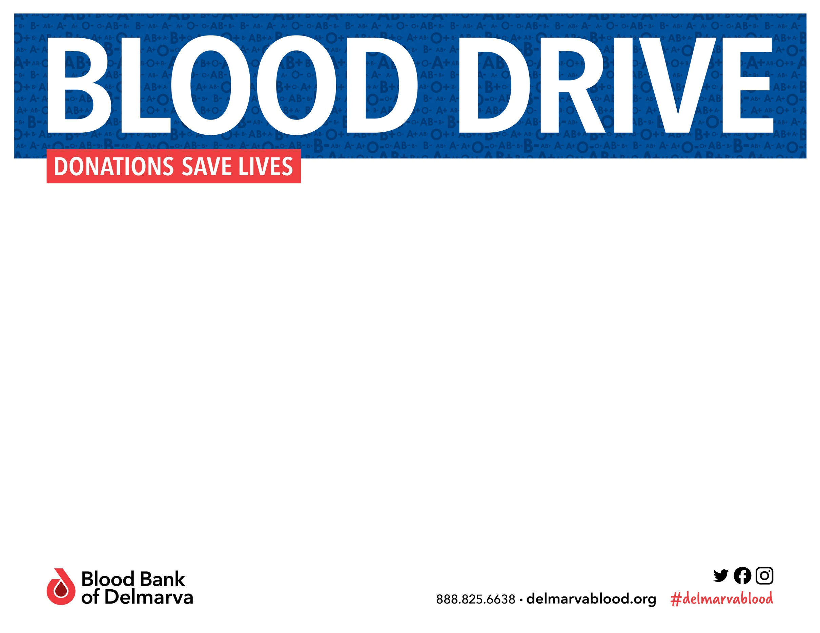
To schedule your donation appointment, scan the QR code, visit the donation portal at https://donate.bbd.org/donor/schedules/drive_schedule/9700 or call 1-888-825-6638
Hosted by:
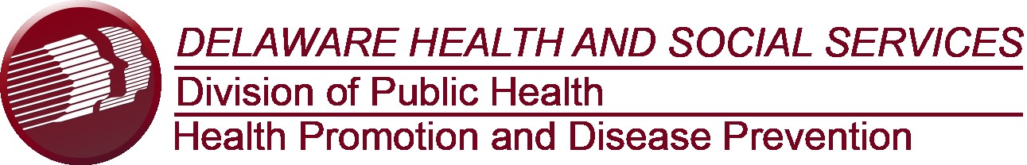

WEDNESDAY, JANUARY 31, 2024
10:00 a.m. to 4:00 p.m.

Blood Bank of Delmarva Blood Mobile
Thomas Collins Building
540 S. Dupont Highway
Dover, DE 19901

For more information contact Dawn Hollinger, Cancer Prevention and Control Bureau Chief, at dawn.hollinger@delaware.gov or 744-1077

Appointments are preferred however walk-ins will be welcomed if space permits. Please remember to eat, drink, and bring your donor ID card or ID with name and photo. Masks are optional for all donors and staff. For full list of COVID-19 safety protocols, please visit delmarvablood.org/coronavirus.

